Project Assignment 6

Rui Zhu, Lingjing Huang, Entisar Seedi M Alshammry

**Activity Diagram**

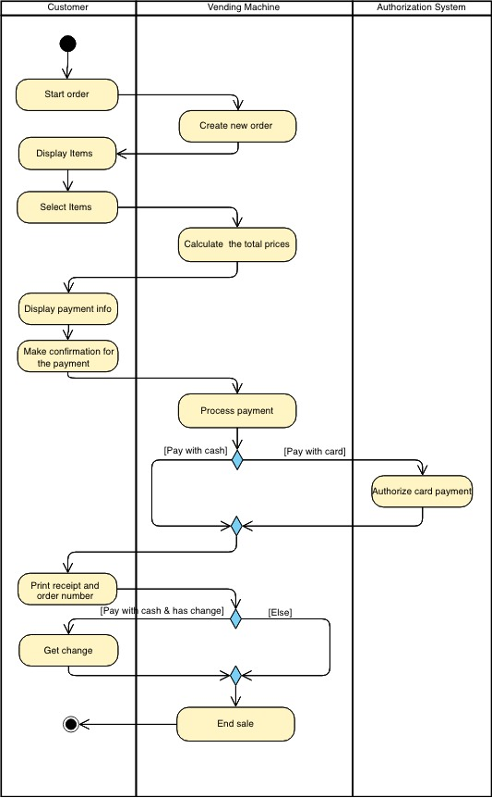

**State Machine Diagram**

